Demographic data

Zuzie

2023-06-26

Loading the packages and data:

Demographic data

1. Age

Outliers: there are 4 values <17 (including 2 values which are negative). There are also 3 values above 110 (including 2 >200 and 1 >900).

This can be seen on the boxplot below:

## Warning: Removed 89 rows containing non-finite values (`stat_boxplot()`).

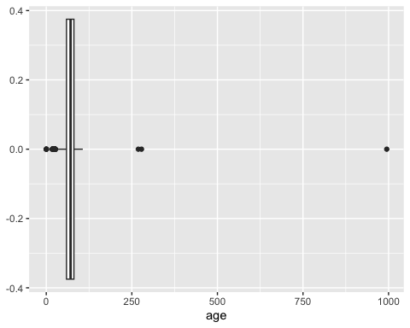 To remove biologically implausible ages:

Repeating the boxplot now doesn’t throw out an error:

## Warning: Removed 94 rows containing non-finite values (`stat_boxplot()`).

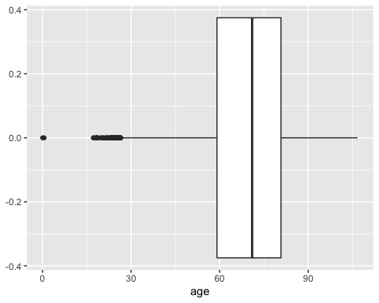

1. Ethnicity

0 patients were missing Ethnicity data.

sum(is.na(slsr$eth6cat))

## [1] 0

sum(is.na(slsr$ethcat))

## [1] 0